Lab 7 CCS3101
30 May 2025
- Solve the following questions and demonstrate your solutions to me in this lab, the next lab (preferred) or at the start of the lab after next. This is a 2-weeks lab. For record-keeping, submit also your solutions and screenshots of their output to PutraBlast.
- Evaluation will be done according to the lab rubric on PutraBlast. I will ask questions accordingly.
*******************************

Question:

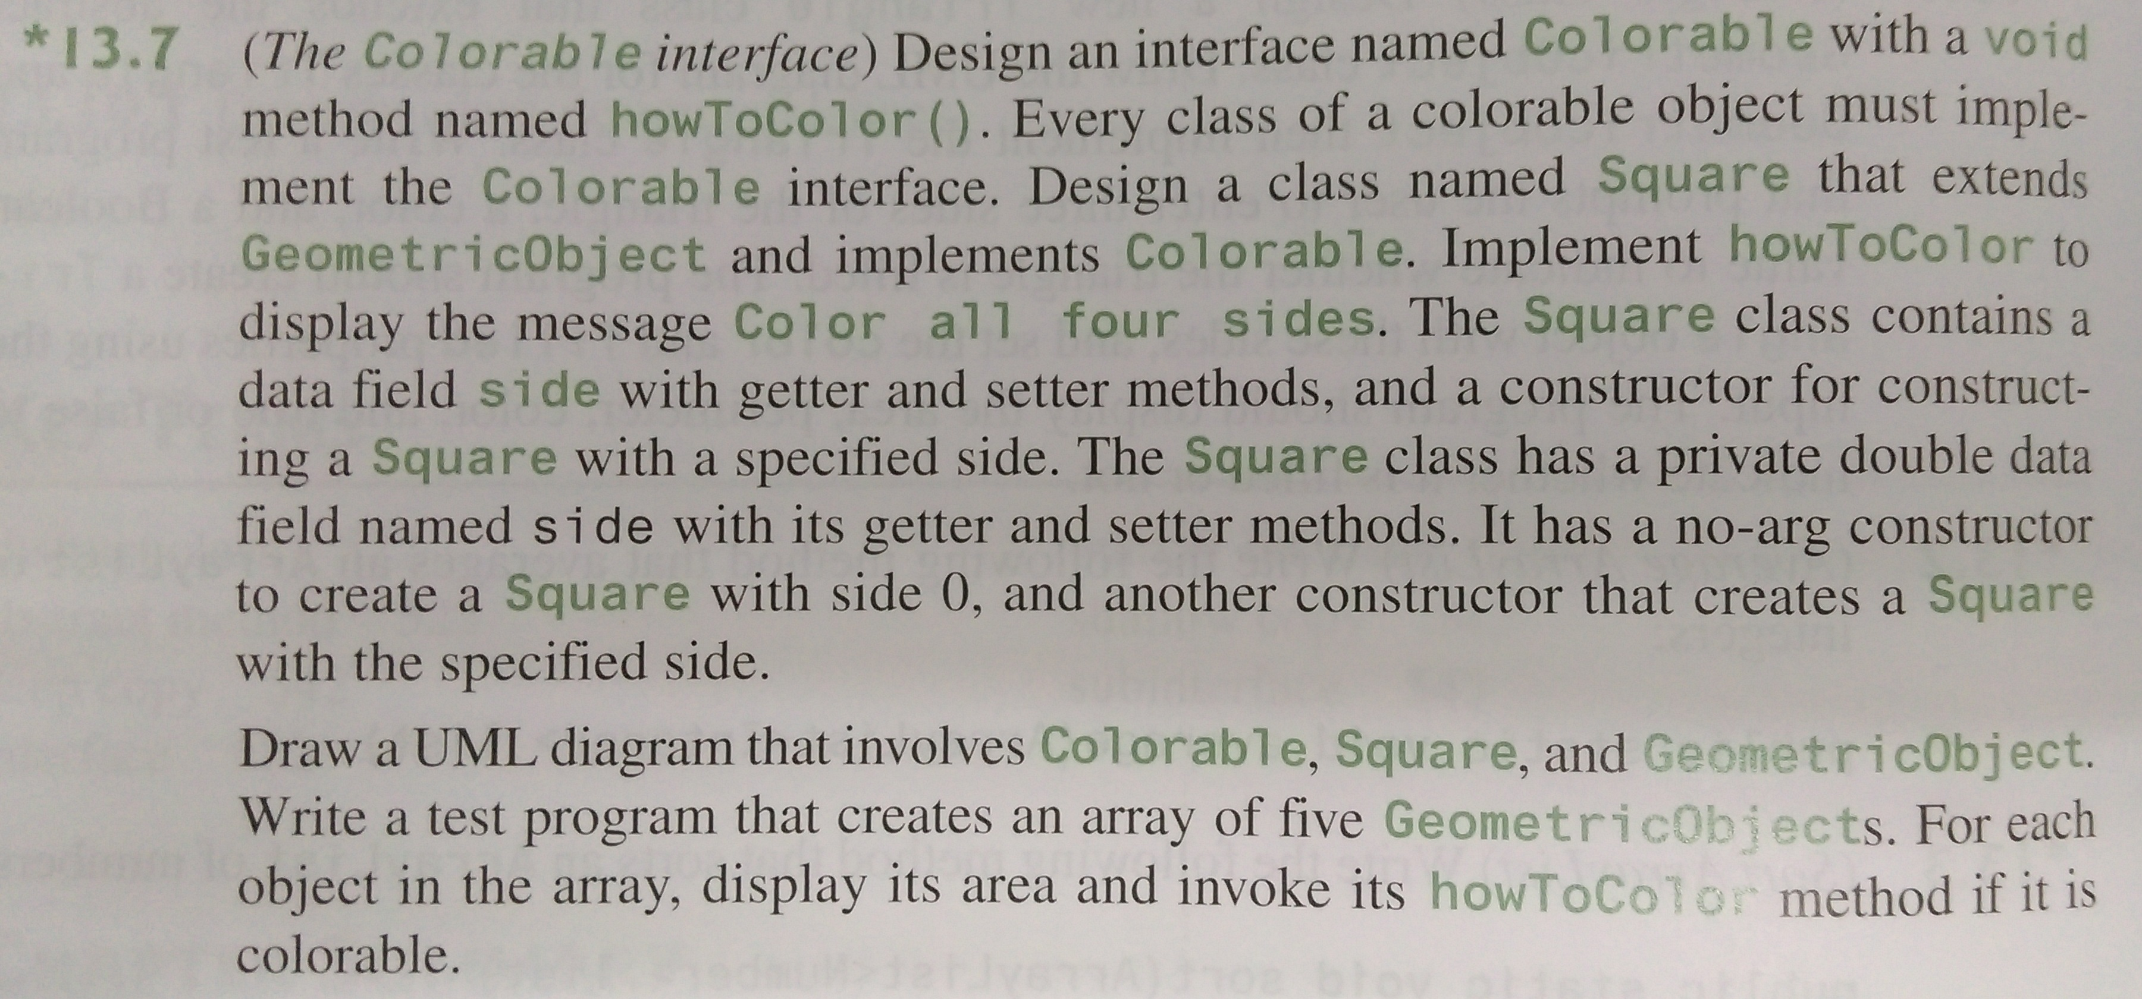

Additional instructions:
- Implement GeometricObject using the code linked to from the slides of Topic 7: Abstract Classes and Interfaces. Also, implement a colorable Circle and a non-colorable Rectangle class in the same way as the Square class above, include those two classes in the UML diagram, and include objects of them in the array.

(Apologies for the American spelling. The question is from the 11th edition of the Liang textbook. A shorter version of the question appears in the 10th edition.)

